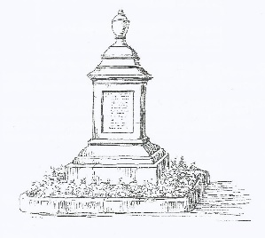
GOTHERINGTON & AREA LOCAL HISTORY SOCIETY
PRIVACY POLICY

Gotherington and Area Local History Society (GALHS) is subject to data protection regulations under UK law, which control the use of personal data.

GALHS will:
- Comply with the data protection laws of the UK.

- Only collect personal data (names, addresses, telephone numbers, email addresses) for the purposes of the administration of the Society and its activities.

- Only contact a member by post, telephone or email if they have given their explicit permission to do so. A member can withdraw that permission at any time by contacting the Society.

- Look after the data and notify members immediately if there has been a data breach.

- Allow a member to see the data held about them and, if necessary, amend that data.

- Review data regularly and, when no longer needed for the administration of the Society (two years after membership has ceased), delete and destroy it carefully so that it cannot be accessed in the future.

- Not pass on the data to a third party without a member’s explicit consent.

*****

Any queries relating to GALHS’s Privacy Policy should be directed to the Chairman.

This policy was agreed at a GALHS committee meeting, 10th March 2018

Review date: January 2020

